Programming in Java
Prof. Debasis Samanta
Department of Computer Science and Engineering
Indian Institute of Technology, Kharagpur
Lecture - 50
JDBC – I

Now, we shall start learning about JDBC. The full form of the JDBC is Java Database Connectivity and these concepts will be covered in 6 sessions including today. So, first, we will learn about actually so, far the JDBC is concerned there are three things to be learned. First of all the database management system and then how the database management system can be connected. And, this itself is called the JDBC driver and then finally, the java application which basically will help a programmer to connect a database from the application as an endpoint.
So, three things are there so, for the database management system is concerned there are many tools many packages are known. In this course, we will cover one system which basically helps a programmer to maintain a database is called the MySQL. So, we will discuss the MySQL and the MySQL is a database management system and then we will discuss about how these MySQL can be installed. If you are new to this MySQL then all this information is highly essential for your learning. So, I do not know exactly whether you are familiar with SQL or MySQL or rather relational database management system anyone.
Anyway so, considering that you do not have any background knowledge about the database management system handling. So, I will take a quick tour of the SQL based database management system which is a very popular one is MySQL. So, in this session, we will try to learn about how the MySQL can be installed. And then finally, we will see exactly using this MySQL if once installs in your machine successfully then how we can manage the database management system related to a task. Namely, how we can create a database management database, how we can create a table under a database and then how you can accomplish different operations to the database.
(Refer Slide Time: 02:40)
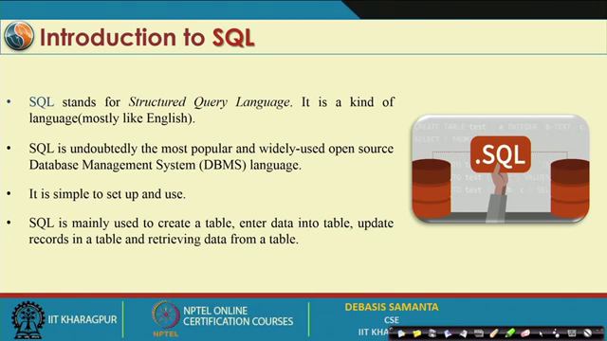
Now so, first what exactly the MySQL it is. So, it is a very popular software usually you know for the database management system handling one language has been provided. It is very popular and a standard language it is called the Structured Query Language. We usually call this language as a fourth-generation language, if we set C, C++, Java they are the third generation language. The language of course, but the thing is that it follows a certain syntax that is why it is sometimes it is called the language, but truly SQL is not a language like Java, C, C++.
Anyway, SQL programming whatever it is there we can do it in English like syntax actually. And it is basically a de facto standard nowadays; every database management system engineer prefers the SQL based system. And, SQL base system is basically followed there are many types of database management systems as relational database management system, object-oriented database management systems; SQL is in fact, a relational database management system. Now, regarding the relational database management system, we will discuss a few things about it, a few salient points about this.

